BLOG POST 4 – Posted, October 15, 2012
Vol 1, No 5

SANDRA WAGNER-WRIGHT’S BLOG
WRITER, HISTORIAN, TRAVELLER

Pub Grub in the City of York

The City of York is situated approximately two hundred miles north of London. The journey takes about 2 hours via high-speed train out of Kings Cross Station in London, or 3 hours in direct driving time. But who wants to go directly on the “M” road when better scenery can be found on the “A” road for only about two hours more in drive time.
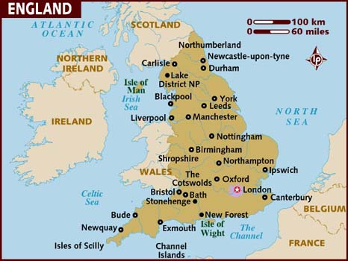
So, it is a very, very, very old city. Did I mention it has the most complete set of medieval walls in England. When the Victorians were busy knocking down walls throughout the land, the City of York could not follow suit due to insufficient funds. But, now, the very same unfashionable walls draw tourists who fuel the economy.

That’s nice, you say, but history is so ho-hum. Well how about pubs? There are lots of places to try traditional English pub grub as well as hybrid delicacies such as chicken tikka marsala, a dish of chicken marinated in yogurt and spices (cinnamon and cumin), served in a tomato cream sauce. [You can find a recipe at http://allrecipes.com/recipe/chicken-tikka-masala/]

One pub I enjoy is the Golden Fleece, 2012 winner of the York Tourism Award. [http://www.thegoldenfleeceyork.co.uk]. It is said the Golden Fleece is the most haunted pub in York. The so-called resident spirit is Lady Alice Peckett, wife of the Lord Mayor of York. When her ghost appears, witnesses comment on Lady Peckett’s perfume.

This is a map of England from lonelyplanet.com. London is marked in pink. If you follow the east coast to the north, you can see York, just above Leeds.

York’s written history begins with the Romans who established Eboracum in 71 A.D., but the site where the Ouse and Foss rivers converge shows signs of habitation since the Neolithic period

